Step 1: Write Down Your Starting %’s
- It is taped on the white board
- OR, it is what you ended at the previous day

Step 2: Write Down Your Ending %’s
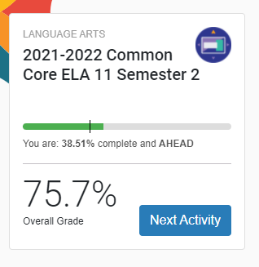

Step 3: Calculate!!
38.51 – 33.89 = 4.62%

Step 4: Repeat for Other Course
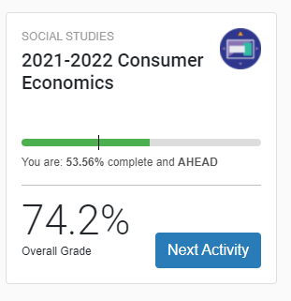
53.56-47.89 = 5.67%

Step 5: Add Ending Total %’s from Both Classes
4.62+5.67 = 10.29% for the day !!!!

